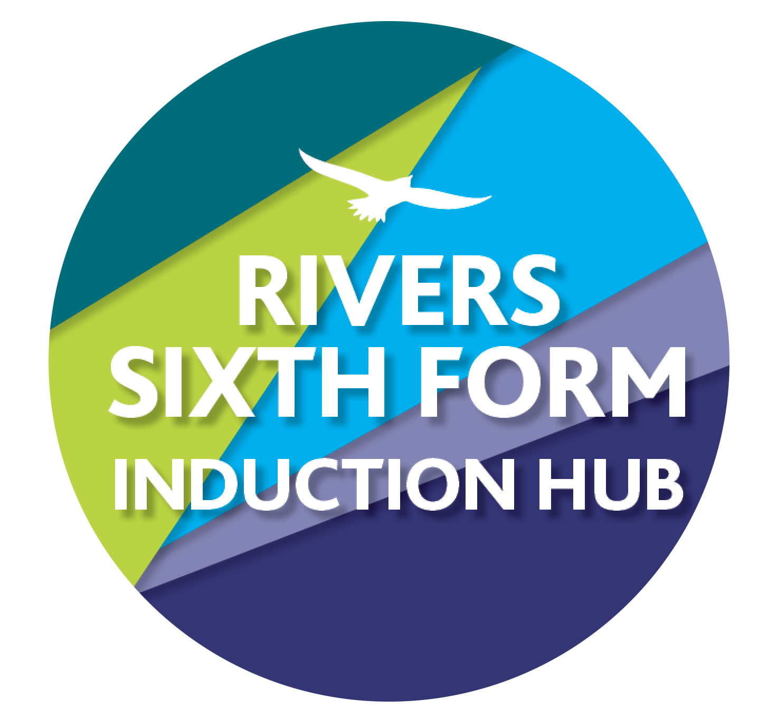
RIVERS TRANSITION CHALLENGE 2020
SUBJECT: Chemistry
Course details: Pearson Edxecel
Qualification: A Level

Minimum entry requirement is: Grade 6 in Chemistry or 6/6 in Combined Science plus 6 in English and 6 in Mathematics
Teacher: Mr Frost wfrost@ormistonriversacademy.co.uk
Classroom Code: 23kcgx4

A-Level chemistry is a demanding course, and it is important to approach it fully prepared. The aim of these challenges is to re-enforce and consolidate the key knowledge and understanding from GCSE’s that underpins the A-Levels content, giving a firm base to build from.

YOUR CHALLENGES:
Challenge 1: Atomic Structure, Formulae and Bonding
Go through the summary sheets, ensuring you understand these key principles, working up through “Building Knowledge” chart.
In A-level Chemistry your notes are exactly that – yours. You will not be directed exactly what to write down. Use this as practise to try different ways of writing up your notes, quickly and legibly for your future reference.
Answer the questions on the Worksheet 1.
Complete the Exam Practice questions, using the Exemplars as a guide of how to maximise marks.
If you want to stretch yourself, and research to find the perfect answers, please add these on afterwards in a different colour, it’s important for me to know where you are ready for the start of the course.

How this links to the specification:
Topic 1: Atomic Structure and the Periodic Table
Time guide: 12 hours
Assignment deadline: 15th May

Exemplars: Exemplar exam answers with examiner comments included.
SUPPORT:
Full set of summary sheets of the content included.
www.chemguide.co.uk

Challenge 2: Quantitative Analysis and Equations

Go through the summary sheets, ensuring you understand these key principles, working up through “Building Knowledge” chart.
Read carefully through the explanations of how to approach these types of questions – highlight the key areas as you go through.
In A-level Chemistry your notes are exactly that – yours. You will not be directed exactly what to write down. Use this as practise to try different ways of writing up your notes, quickly and legibly for your future reference.
Answer the questions on the Worksheets 1 and 2.
Complete the Exam Practice questions, using the Exemplars as a guide of how to maximise marks.
If you want to stretch yourself, and research to find the perfect answers, please add these on afterwards in a different colour, it’s important for me to know where you are ready for the start of the course.

How this links to the specification: Mathematical Skills. Essential throughout course
Topic 5 – Formula, Equations and Amount of Substance
Time guide: 14 hours
Assignment deadline: 5th June

Exemplars: Exemplar exam answers with examiner comments included.
SUPPORT:
Full set of summary sheets of the content included.
www.chemguide.co.uk

Challenge 3: Structure and Properties – Literacy Focus

Go through the summary sheets, ensuring you understand these key principles, working up through “Building Knowledge” chart.
Read carefully through the explanations of how to explain the properties of substances in the example given.
In A-level Chemistry your notes are exactly that – yours. You will not be directed exactly what to write down. Use this as practise to try different ways of writing up your notes, quickly and legibly for your future reference.
Use the example, and the key words provided, to describe and explain how the structure of sodium fluoride is formed.
Complete the Exam Practice questions, using the Exemplars as a guide of how to maximise marks.
If you want to stretch yourself, and research to find the perfect answers, please add these on afterwards in a different colour, it’s important for me to know where you are ready for the start of the course.

How this links to the specification:
Time guide: 14 hours
Assignment deadline: 26th June

Exemplars: Exemplar exam answers with examiner comments included.
SUPPORT:
Full set of summary sheets of the content included.
www.chemguide.co.uk

HOW DO I HAND IN:
Your work must be handed in via Google Classroom so that it can be assessed and marked accordingly, all of your challenge deadlines are also in there as assignments (1,2 and 3) You can simply upload the work (by clicking plus and hand in)

HOW AM I MARKED?
You are graded using A to E grades using standard grade boundaries. The tasks may be difficult because it’s Sixth Form and KS5 study and there is a big jump from GCSE. You will need to spend significant time learning the concepts and techniques.
We would expect new students to any course to be sitting at the bottom of the grading structure, but there are certain activities that you will be more familiar with and will do better with.

WHAT IF I GET STUCK?
Then email me, my email is in the title of this sheet or write on the thread in our classroom, we know some things are tricky and are here to help!

WHAT IF I MISS A DEADLINE OR DON’T HAVE I.T?
You need to let me know in advance so we can support you. If you miss the deadline you are risking your course offer.

THAT'S IT! Good luck and don’t miss your deadlines! All 3 deadlines will also be in the Google Classroom.

