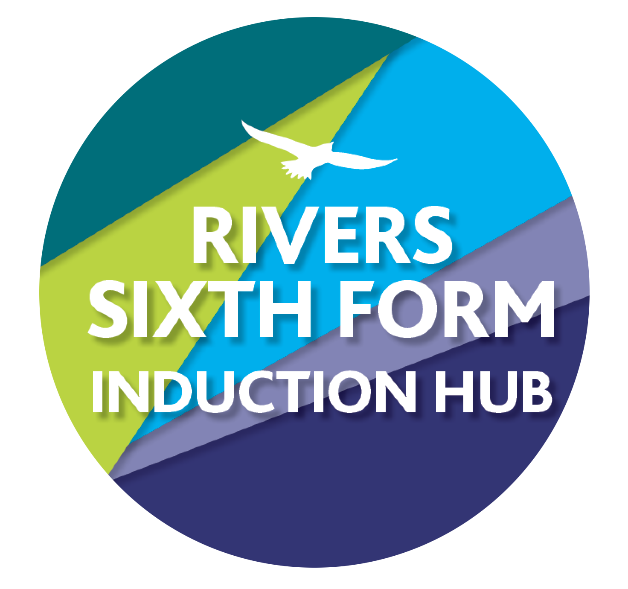
RIVERS TRANSITION CHALLENGE 2020
SUBJECT: Biology
Course details: Pearson Edexcel
Qualification: A Level

Minimum entry requirement is: Grade 6 in Physics or 6/6 in Combined Science plus 6 in English and 6 in Mathematics
Teacher: Mr Rigler trigler@ormistonriversacademy.co.uk
Mrs Hoare choare@ormistonriversacademy.co.uk
Classroom Code: nctnkhr

YOUR CHALLENGES:
Challenge 1: Describe in detail how the processes of transcription and translation produce proteins and how mutations can lead to changes in the protein produced.
Use your knowledge from GCSE, together with four additional sources, to produce a summary demonstrating your understanding of how protein synthesis and the effect of mutations. You can then submit this and I will be happy to give feedback.
How this links to the specification:
i) Understand the process of protein synthesis (transcription) including the role of RNA polymerase, translation, messenger RNA, transfer RNA, ribosomes and the role of start and stop codons.
ii) Understand the roles of the DNA template (antisense) strand in transcription, codons on messenger RNA and anticodons on transfer RNA.

Time guide: 5 hrs
Assignment deadline: 22nd May

EXEMPLARS: I want to see how your research and report skills are and any exemplars would give you the answers

SUPPORT: Use the links on the GoogleClassroom

Challenge 2:
The Heart Research task

How this links to the specification: The first topic in A Level Biology is ‘Lifestyle, Health and Risk’. This topic builds on your existing knowledge and understanding of the functioning of the circulatory system and the importance of lifestyle choices to health. The role of diet and other lifestyle factors in maintenance of good health is considered with particular reference to the heart and circulation and to cardiovascular disease. This task focuses on two points from the specification;

1.4 Know the cardiac cycle (atrial systole, ventricular systole and cardiac diastole) and relate the structure and operation of the mammalian heart, including the major blood vessels, to its function.
1.5 Understand the course of events that leads to atherosclerosis (endothelial dysfunction, inflammatory response, plaque formation, raised blood pressure).

Time guide: 5 hrs
Assignment deadline: 22nd May

EXEMPLARS: GRADE N/A

SUPPORT: Use the videos given with the assignment in Google classroom, together with your GCSE books, A level textbook if available and further online resources such as A level biology tutor https://www.alevelbiologytutor.com/tutoring-blog/2017/12/1/cardiac-cycle-and-transport-in-animals-questions

Challenge 3: Biology Maths Student Guide
Work through the Biology Maths Student Guide by reading the worked examples and then completing the practice questions up to and including page 25.
How this links to the specification: Mathematical skills are an essential part of AS and Advanced Level Biology and your knowledge and understanding of these skills will be assessed in the examinations for this
subject.

Time guide: 5 hrs
Assignment deadline: 20th June

EXEMPLARS: GRADE: NA

SUPPORT: The booklet will support you throughout.

Challenge 4:The Transition guide
Work through the GCSE to A Level Biology transition guide. This will take at least 15 hours. I will post the mark scheme after the due date for you to self assess. A paper copy can be obtained from school.
Time guide: 15 hrs
Assignment deadline: 20th June

Challenge 5:A researched Essay
Diseases such as TB and gonorrhea are caused by a bacterial infection whereas infections such as HIV/AIDS and Covid-19 are caused by a virus. How does the body respond to these pathogens?
Conduct effective research describing the immune response to both bacteria and viruses and explain why diseases caused by a virus are typically more difficult to treat. Also include a comparison of the treatments which are currently available to treat both bacterial and viral infections.

Present your findings as a 1000 word essay response.

Time guide: 10 hrs
Assignment deadline: 20th June

HOW DO I HAND IN:
Your work must be handed in via Google Classroom so that it can be assessed and marked accordingly, all of your challenge deadlines are also in there as assignments (1,2, 3, 4 and 5!) You can simply upload the work (by clicking plus and hand in), work can be submitted photographically, written, Sheets and Powerpoints and/or video flickthroughs for instance.

HOW AM I MARKED?
You are graded using A to E grades using standard grade boundaries . The tasks are tricky because it’s Sixth Form and KS5 study and there is a big jump. You will need to spend significant time learning the concepts and techniques.
We would expect new students to any course to be sitting at the bottom of the grading structure, BUT! There are certain activities that you will be familiar with and will do better with even though it is just the start of the course. Please don't worry if you receive Us and Es.

WHAT IF I GET STUCK?
Then email me, my email is in the title of this sheet or write on the thread in our classroom, we know some things are tricky and are here to help!

WHAT IF I MISS A DEADLINE OR DON’T HAVE I.T?
THEN YOU NEED TO LET ME KNOW WAY IN ADVANCE SO WE CAN SUPPORT YOU, IF YOU JUST MISS THE DEADLINE YOU ARE RISKING YOUR COURSE OFFER.

THATS’S IT! Good luck and don’t miss your deadlines! All 5 deadlines will be in Google Classroom also.

