Who should read this guide?

This guide is intended for use by parents, students and school staff registering accounts with SIMS Online Services. School staff registering as administrators after the Service has been set up can also use this guide.
IMPORTANT NOTE: The Administrator responsible for registering the school during setup of the service should not use this guide. The initial administrator should refer instead to the guidance on Joining SIMS Online Services in the SIMS Parent and SIMS Parent Lite Setup Guide (https://myaccount.capita-cs.co.uk/hot-topics/sims-parent-app-student-app/).

How do I register?

NOTE: Users with multiple roles need to register only once. For example, users who are both a parent and a teacher should register as either a parent or a teacher but should not register as both. Once registered, all of the relevant parent and teacher information will be available.
- You will receive a registration email from noreply@sims.co.uk containing a unique invitation code. You will need this code to set up your SIMS Online Services account. If you have not yet received a registration email, please check your SPAM folder before contacting your school.
IMPORTANT NOTE: To register for SIMS Online Services products, you will need one of the following accounts: Microsoft, Office 365, Google, Facebook, Twitter or SIMS ID.
Only users with an existing SIMS ID account can use SIMS ID to register.
For guidance on setting up a Third Party account, please refer to the Setting up a Microsoft or Google Account document, which is available from the Hot Topics area of My Account (https://myaccount.capita-cs.co.uk/hot-topics/sims-parent-app-student-app/).
- Follow the link in the email to be directed to the registration page.
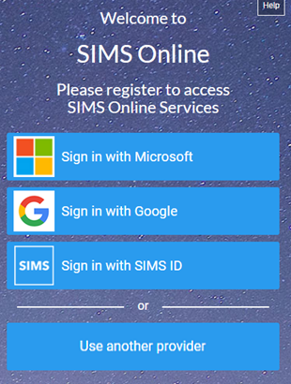
- Click the button for your preferred account and you will be directed to sign in.
- Users who already have a SIMS ID account can sign in with SIMS ID.
- Users who do not have a SIMS ID account should register with a Microsoft (including Office 365), Google, Facebook or Twitter account.
- To use Facebook or Twitter, click the Use another provider button.
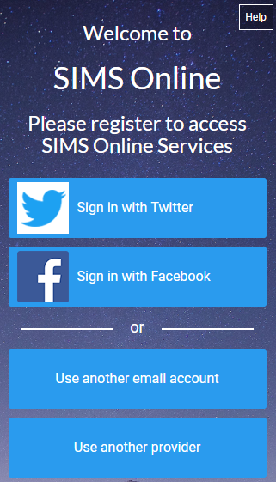
- The Use another email account button launches the Microsoft Create account page (https://signup.live.com/), where you can create a Hotmail account.
- The Use another provider button returns you to the previous screen.
- Having selected your account provider, follow the on-screen registration process.

How do I sign in?

Once the registration process is complete, users can sign in via the following URLs.
For Parents https://www.sims-parent.co.uk
or via the SIMS Parent app*
For Students https://www.sims-student.co.uk
or via the SIMS Student app*
For Schools
- Product Admin Portal https://admin.sims.co.uk
- Parental Engagement Portal https://www.sims-engagement.co.uk
- Activities Portal https://organiser.sims-activities.co.uk
* The apps are available for iOS and Android devices via the Play Store or iTunes.
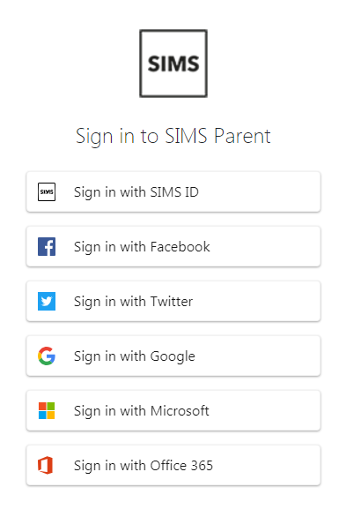
- Click the icon for the account that you registered with.
A new window will open.
- Enter your sign in details.

Why can’t I register?

- If you do not have a SIMS ID account, you should register with a Microsoft, Office 365, Google, Facebook or Twitter account. Click the icon for the relevant Third Party account and you will be directed to sign in using your existing details. If you try to enter your Microsoft, Office 365, Google, Facebook or Twitter details in the SIMS ID Username and Password fields, the following error will be displayed.
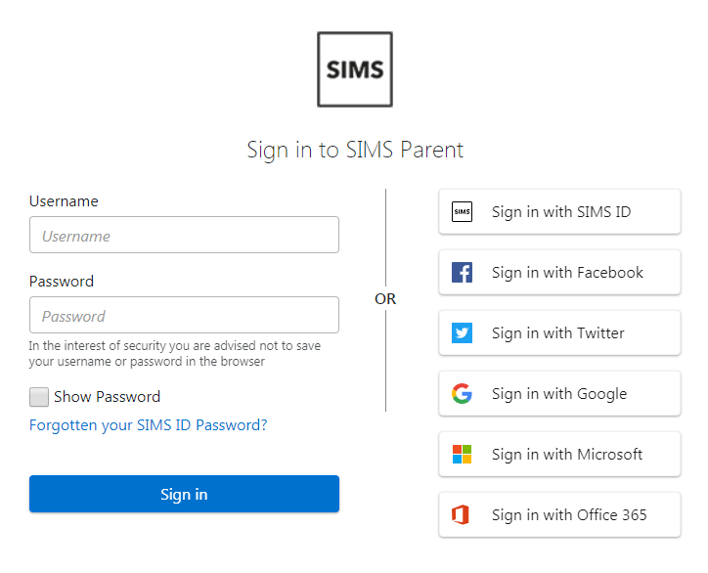
- Before completing the registration process, users should be signed out from all accounts. Alternatively, the registration process should be carried out in a private browser window.
- If you have forgotten your password, please contact Microsoft, Office 365, Google, Facebook or Twitter and request a new password.

Who do I contact for help?

If you have a question about your SIMS Online Services Account, please contact your school.
Once you have signed into your SIMS Online Services product, further help is available by selecting Help from the menu or clicking the item in the footer.

